Aesthetics
Aesthetics is concerned with how things look. This can be influenced by an objects' appearance and its style. The appearance of an object is the feature that people notice first. In some ways appearance can be very personal and is influenced by things like the materials from which the object is made and the type of finish applied to its surface

It is important that products have visual appeal. In a world where many new products function in a similar way, it is often the appearance which sells the product. Aesthetics is a pan of design which is difficult to analyse and describe in words. However there are aspects of appearance which can be considered separately.

Line
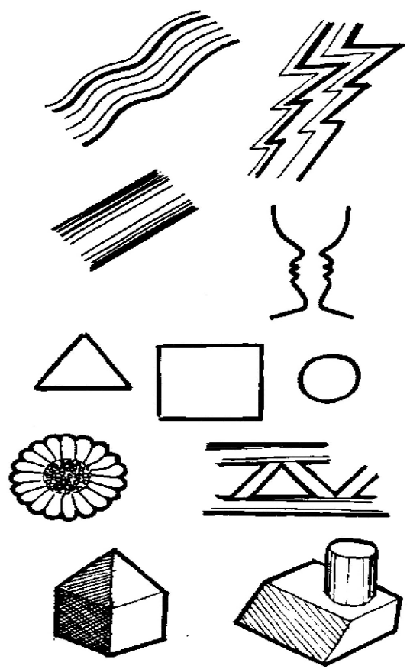
Lines are the basic starting point in our attempts to represent design ideas. We use lines to enclose space and create shapes. Lines can be used to express feelings and emotion. Lines may be thick or thin, solid or broken, straight or curved. By changing the type of line many visual effects can be created. Straight or wavy lines can express rhythm, give the impression of light and shade as well as texture. A feeling of anxiety, depression and calm can be created. Lines can be used to deceive the eye.

Shape and Form
These terms are often confused. Shape is created when lines overlap and cross to create an enclosed space. Shapes are two dimensional. Shapes can be used as the starting point for a design, e.g.

Geometric shapes - Circles, squares etc. Natural shapes - Sea shells, flowers etc. Man made shapes - Bridge structures etc.

Form is three dimensional. To describe a form fully it is necessary to give details of its shape, size, proportion, colour and texture. When experimenting with form it is generally best to start with simple geometric forms such as cubes and cylinders. These forms can then be manipulated to create more complex forms.

Size and proportion
The size of an object is found by measuring its length, width, and height. These are known as linear dimensions. Proportion is the relationship between an object's height compared to its width.

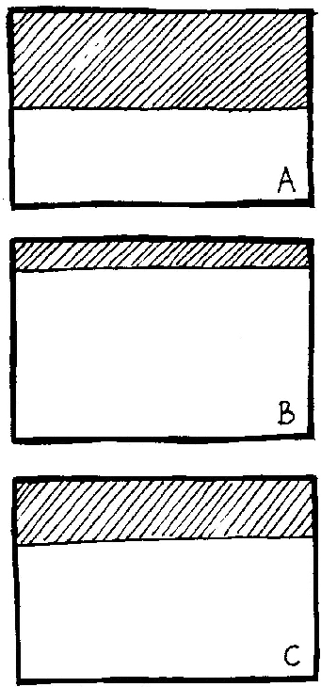
The Greeks discovered that certain proportions looked much better than others. This idea of proportion which looks right is called the golden section. The golden section can be applied to any shape or form but it is best illustrated by looking at a landscape with the horizon placed in a position which gives the landscape balance.

Landscape A and B do not have visual balance whereas C does. In C the proportion of sky to land is just right. This proportion is the golden section and can be seen in architecture, paintings and products alike.

Symmetry
Symmetry is when a shape or form can be divided down the middle and one half is the mirror image of the other. A shape or form which is not symmetrical is asymmetrical.

Pattern
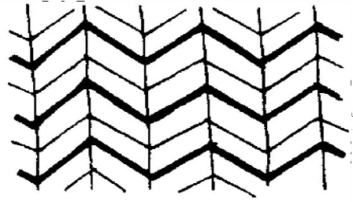
Pattern involves the division of area. Pattern helps to create interest to plain surfaces. Patterns can be random or made up from elements which are repeated. Patterns can be used to create rhythm and movement.

Colour
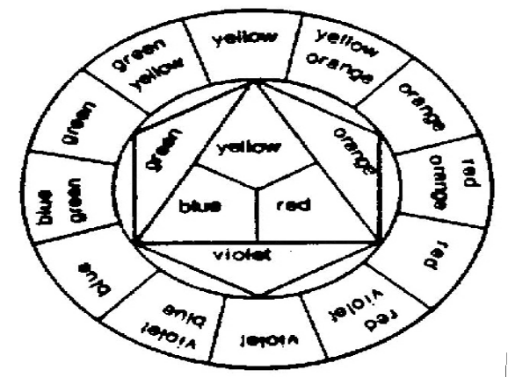
Colour has no form, but can complement form. Used badly colour can completely ruin a design. Alternatively, used well colour can make a good design great! Colours can be mixed. Mixing primary colours at the centre of the colour wheel produces secondary colours. These secondary colours can be further mixed to create tertiary colours. Colours close to each other on the
colour wheel produce harmony e.g. red and orange. Colours opposite each other on the colour wheel create contrast e.g. red and green. Colour has three properties:-

Intensity - brightness e.g. bright red or dull red.

Temperature - warm colours e.g. red and orange. Cold colours e.g. blue and green.

Tone - the lightness or darkness of a colour. Small quantities of white or black can be added to basic colours to create light and dark shades of a colour.

Texture and Finish
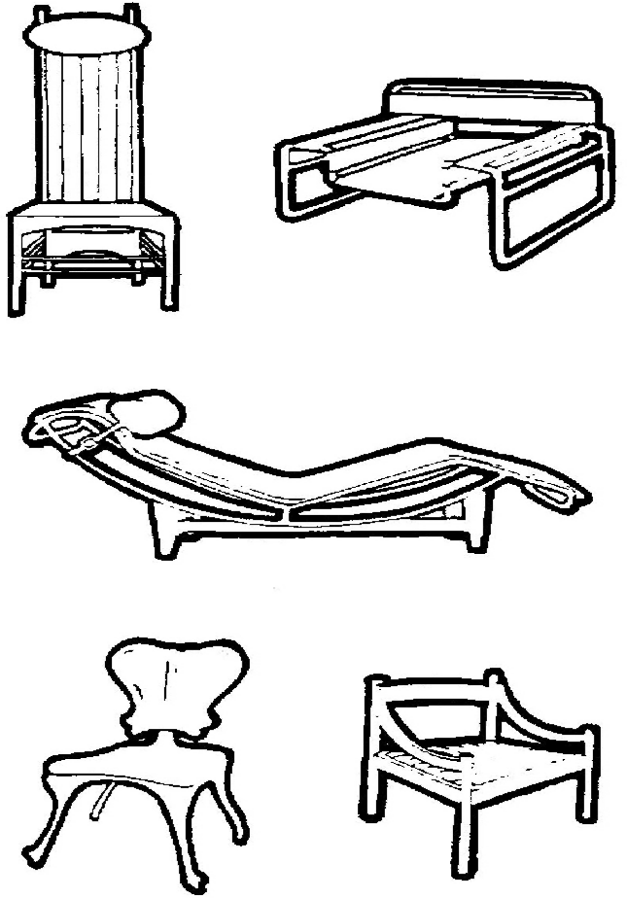
The surface of an object is the part which is most seen. Texture and finish are used to enhance their appearance and improve function e.g. textured hand grips.

Style
The style of an object is created by combining tone, colour, texture, form etc. Many designers have a recognisable style which they apply to their work e.g. Charles Rennie Mclntosh's Glasgow style.
Style is constantly changing, what is popular today may not be popular in a year or two. The designer has the responsibility of making sure that the style of his or her design will appeal to those who will buy it. Art Nouveau, Victorian and Gothic are well known styles. Each style has its own particular look. Whilst designers have argued for years over the importance of style and function, it is probably true to say that the best designs have a good balance of the two.

When you come to design a product you should try to take account of aesthetics - but remember a design which looks great but doesn't work or is difficult to use is not a good design!

