What is a Break-Even Analysis?
A break-even analysis is a financial tool which helps you to determine at what stage your company, or a new service or a product, will be profitable. In other words, it’s a financial calculation for determining the number of products or services a company should sell to cover its costs (particularly fixed costs). Break-even is a situation where you are neither making money nor losing money, but all your costs have been covered.
Break-even analysis is useful in studying the relation between the variable cost, fixed cost and revenue. Generally, a company with low fixed costs will have a low break-even point of sale. For an example, a company has a fixed cost of Rs.0 (zero) will automatically have broken even upon the first sale of its product.
- Components of Break Even Analysis
- Fixed costs
Fixed costs are also called as the overhead cost. These overhead costs occur after the decision to start an economic activity is taken and these costs are directly related to the level of production, but not the quantity of production. Fixed costs include (but are not limited to) interest, taxes, salaries, rent, depreciation costs, labour costs, energy costs etc. These costs are fixed no matter how much you sell.
- Variable costs
Variable costs are costs that will increase or decrease in direct relation to the production volume. These cost include cost of raw material, packaging cost, fuel and other costs that are directly related to the production.

- Calculation of Break-Even Analysis
The basic formula for break-even analysis is driven by dividing the total fixed costs of production by the contribution per unit (price per unit less the variable costs).

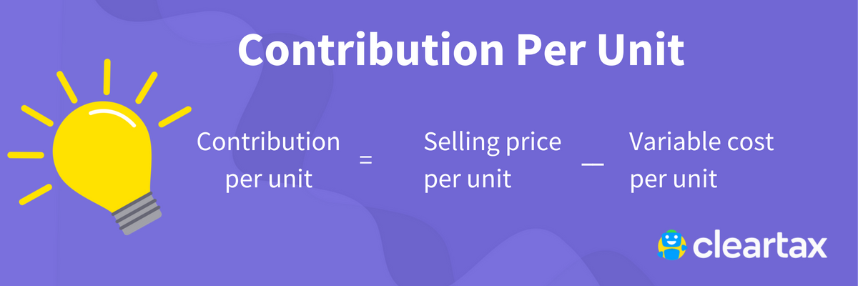

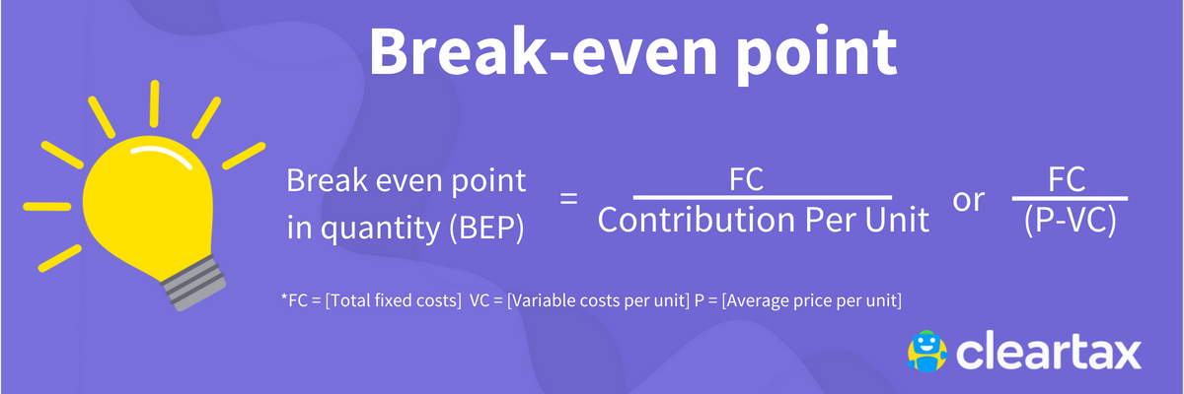

Contribution Margin

Break-even analysis also deals with the contribution margin of a product. The excess between the selling price and total variable costs is known as contribution margin. For an example, if the price of a product is Rs.100, total variable costs are Rs. 60 per product and fixed cost is Rs. 25 per product, the contribution margin of the product is Rs. 40 (Rs. 100 – Rs. 60). This Rs. 40 represents the revenue collected to cover the fixed costs. In the calculation of the contribution margin, fixed costs are not considered.

- When is Break even analysis used?
- Starting a new business: If you wish to start a new business, a break-even analysis is a must. Not only it helps you in deciding, whether the idea of starting a new is viable, but it will force you to be realistic about the costs, as well as guide you about the pricing strategy.
- Creating a new product: In the case of an existing business, you should still do a break-even analysis before launching a new product—particularly if such a product is going to add a significant expenditure.
- 3.Changing the business model: If you are about to the change your business model, like, switching from wholesale business to retail business, you should do a break-even analysis. The costs could change considerably and this will help you to figure out the selling prices need to change too.
- Breakeven analysis is useful for the following reasons:
- It helps to determine remaining/unused capacity of the concern once the breakeven is reached. This will help to show the maximum profit on a particular product/service that can be generated.
- It helps to determine the impact on profit on changing to automation from manual (a fixed cost replaces a variable cost).
- It helps to determine the change in profits if the price of a product is altered.
- It helps to determine the amount of losses that could be sustained if there is a sales downturn.
- Additionally, break-even analysis is very useful for knowing the overall ability of a business to generate a profit. In the case of a company whose breakeven point is near to the maximum sales level, this signifies that it is nearly impractical for the business to earn a profit even under the best of circumstances.
Therefore, it’s the management responsibility to monitor the breakeven point constantly. This monitoring certainly reduces the breakeven point whenever possible.

- Ways to monitor Break even point
- Pricing analysis: Minimize or eliminate the use of coupons or other price reductions offers, since such promotional strategies increase the breakeven point.
- Technology analysis: Implementing any technology that can enhance the business efficiency, thus increasing capacity with no extra cost.
- Cost analysis: Reviewing all fixed costs constantly to verify if any can be eliminated can surely help. Also, review the total variable costs to see if they can be eliminated. This analysis will increase the margin and reduce the breakeven point.
- Margin analysis: Push sales of the highest-margin (high contribution earning) items and pay close attention to product margins, thus reducing the breakeven point.
- Outsourcing: If an activity consists of a fixed cost, try to outsource such activity (whenever possible), which reduces the breakeven point.
- Benefits of Break-even analysis
- Catch missing expenses: When you’re thinking about a new business, it’s very much possible that you may forget about few expenses. Therefore, if you do a break-even analysis you have to review all your financial commitments to figure out your break-even point. This analysis certainly restricts the number of surprises down the road.
- Set revenue targets: Once the break-even analysis is complete, you will get to know how much you need to sell to be profitable. This will help you and your sales team to set more concrete sales goals.
- Make smarter decisions: Entrepreneurs often take decisions in relation to their business based on emotion. Emotion is important i.e. how you feel, though it’s not enough. In order to be a successful entrepreneur, your decisions should be based on facts.
- Fund your business: This analysis is a key component in any business plan. It’s generally a requirement if you want outsiders to fund your business. In order to fund your business, you have to prove that your plan is viable. Furthermore, if the analysis looks good, you will be comfortable enough to take the burden of various ways of financing.
- Better Pricing: Finding the break-even point will help in pricing the products better. This tool is highly used for providing the best price of a product that can fetch maximum profit without increasing the existing price.
- Cover fixed costs: Doing a break-even analysis helps in covering all fixed cost.

